**Analysis of Preferred Style by Average Age**

I analyzed the data and found that the average age of customers varies by their preferred style. For example, customers who prefer Sport-Protective and Eclectic styles have an average age of 25.0, while customers who prefer Classic style have an average age of 50.6.

|  |  |
| --- | --- |
| **Preferred Style** | **Average of Average Age** |
| Classic | 50.6 |
| Modern | 45.5 |
| Vintage | 45.0 |
| Sport-Comfort | 42.5 |
| Eclectic | 25.0 |
| Sport-Protective | 25.0 |
| **Grand Total** | **43.5** |

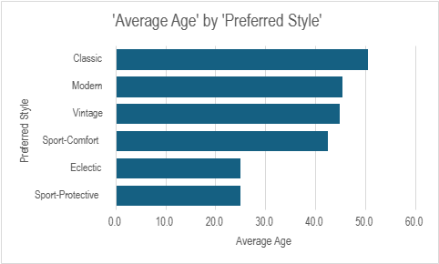

**Analysis of Satisfaction by Important Factors**   
I analyzed the data and found that the average satisfaction level varies by the important factors customers consider when purchasing glasses. For example, customers who consider Technology as an important factor have an average satisfaction level of 5, while customers who consider Vision Change as an important factor have an average satisfaction level of 4.

|  |  |  |
| --- | --- | --- |
|  | |  |
|  | **Important Factors** | **Average of Satisfaction** |
|  | Technology | 5 |
|  | Vision Change | 4 |
|  | Damaged Glass | 3 |
|  | Style | 3 |
|  | **Grand Total** | **4** |



  
  
  
  
  
  
  
  
  
  
  
  
  
  
  
  
  
  
  
  